Lab Report – 6

Part A: 4 Bit Up Down Counter

Moida Praneeth Jain (2022101093, Group 4, Table 16)

**Objective**

* To design, assemble and test a 4 bit up down counter that counts up from 0 to 15, and then counts down from 15 to 0.

**Electronic Components Required**

* LEDs
* Resistors
* Wires
* Arduino Uno

**The Reference Circuit**

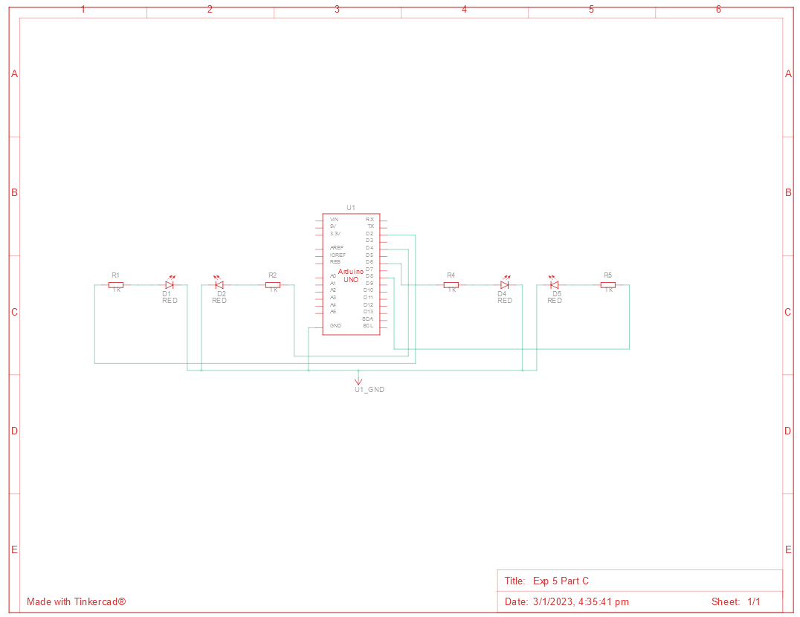

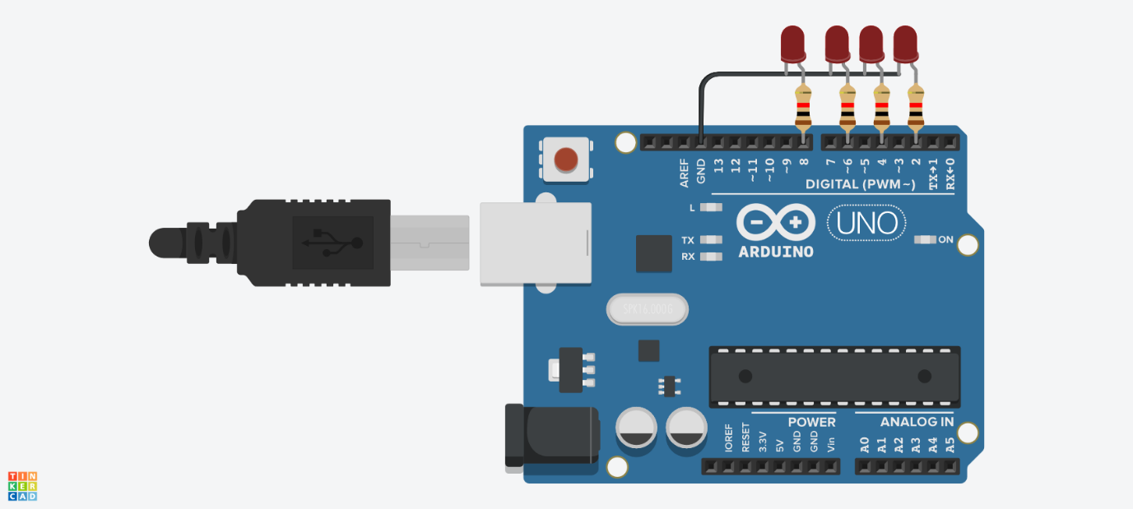

**Procedure**

* Connect 4 pins of Arduino to LEDs’ anodes through resistors.
* Connect the LEDs’ cathode to the Arduino’s GND.
* Oscillate each bit at half the frequency of the previous one, to create the effect of an up counter.
* Change the oscillation direction after 16 delays by flipping low to high.
* Repeat this in a loop to get an up down counter.

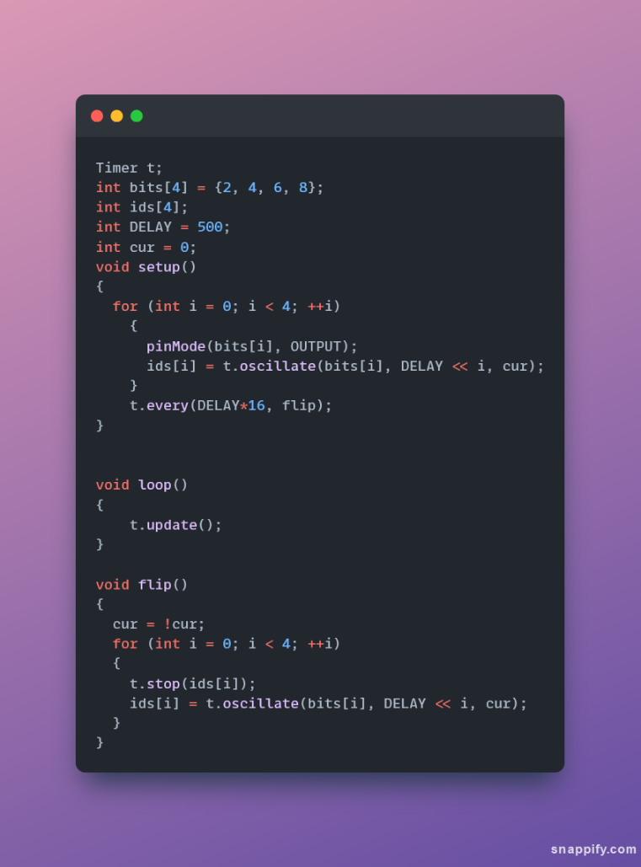

**Observation**

* The 4 bit up down counter counts up from 0 to 15 in binary, and then counts down from 15 to 0 in binary.

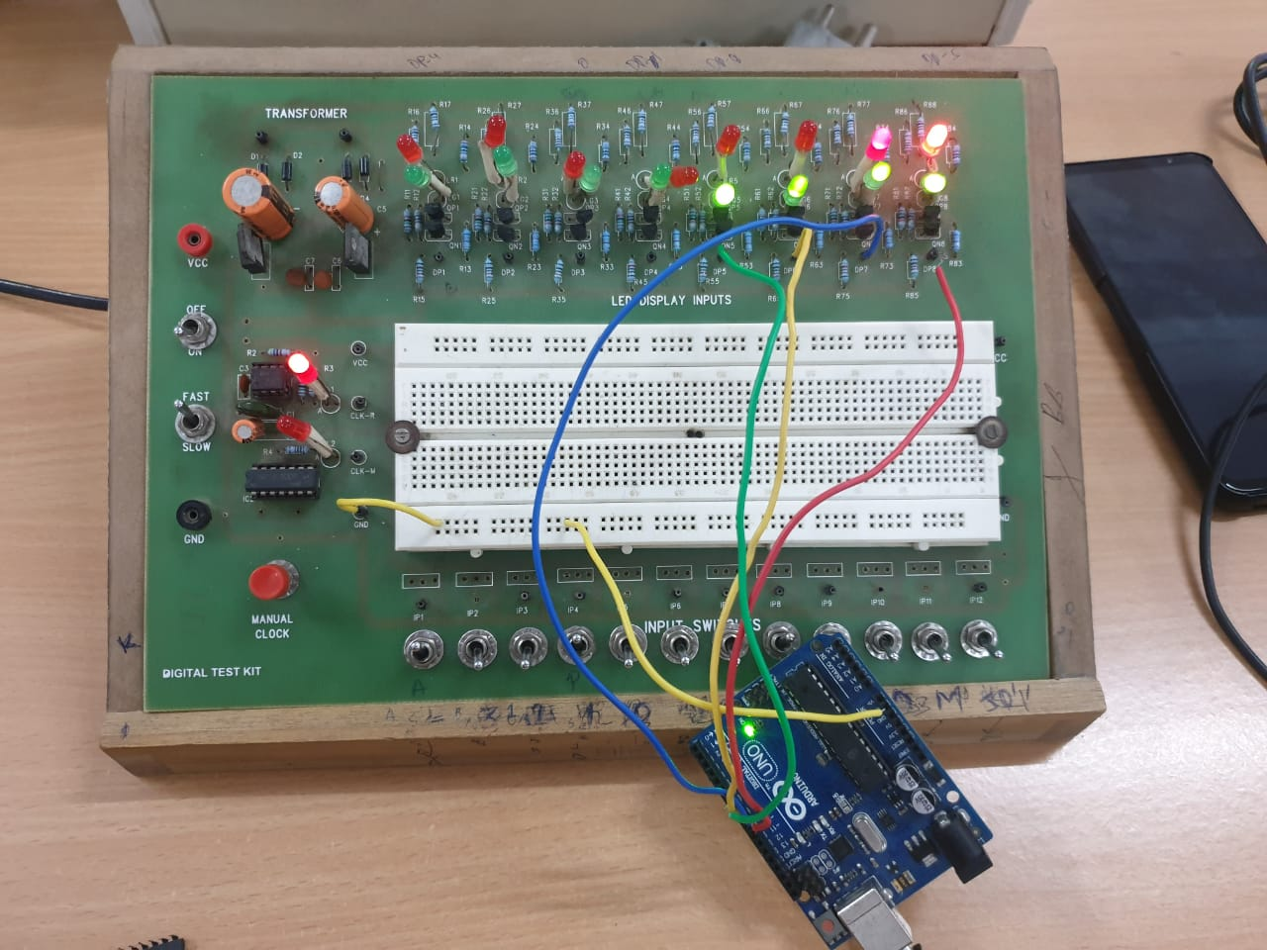

**Conclusion**

* The 4 bit up down counter is working as expected.

TinkerCAD simulation link:

<https://www.tinkercad.com/things/2jigfMnBOXS-exp-5-part-c/editel?sharecode=RTbas_MHMiWMdZH8H0G0PQ1PklAfVhzqDDoei7MgEqY>

Part B: Decade Counter

Moida Praneeth Jain (2022101093, Group 4, Table 16)

**Objective**

* To design, assemble and test a decade counter to count from 0 to 9 on a seven-segment display, and then reset back to 0.

**Electronic Components Required**

* Power Supply
* Breadboard
* LEDs
* Resistors
* Capacitors
* Wires
* IC 555 (Timer)
* IC 7493 (4-Bit Binary Counter)
* IC 4511 (7-Segment Decoder)
* 7 Segment Display

**The Reference Circuit**

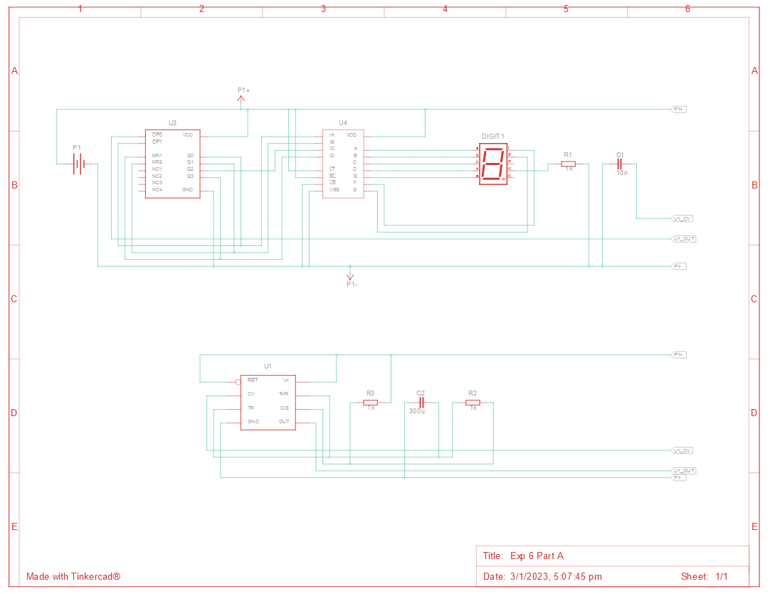

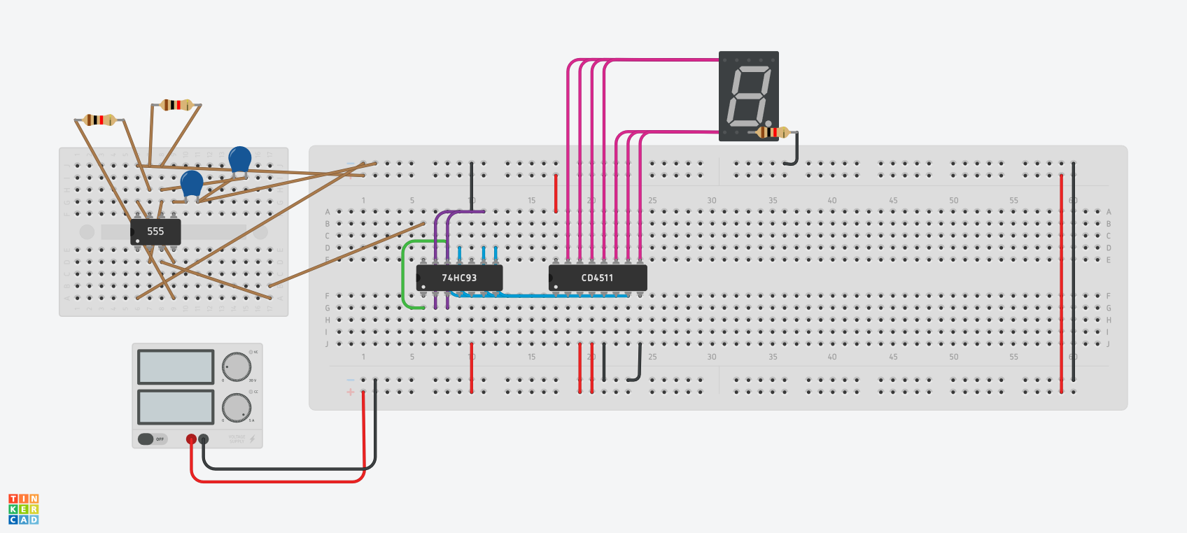

**Procedure**

* Connect the power and ground of the ICs to VCC and GND of the power supply using red and black wires respectively.
* Make a 1 second timer using the 555 IC and feed that as input for the binary counter.
* Reset the binary counter whenever the count reaches 10 (1010), i.e., reset the binary counter whenever output bit 3 and output bit 1 are both 1.
* Pass the outputs of the binary counter to the inputs of the 7-segment decoder.
* Connect the outputs of the 7-segment decoder to the inputs of the 7-segment display.
* Connect the common of the 7-segment decoder through a resistor to GND if it is common cathode, or to VCC if it is common anode.

**Observation**

* The decade counter displays numbers from 0 to 9, and then resets back to 0 after that.

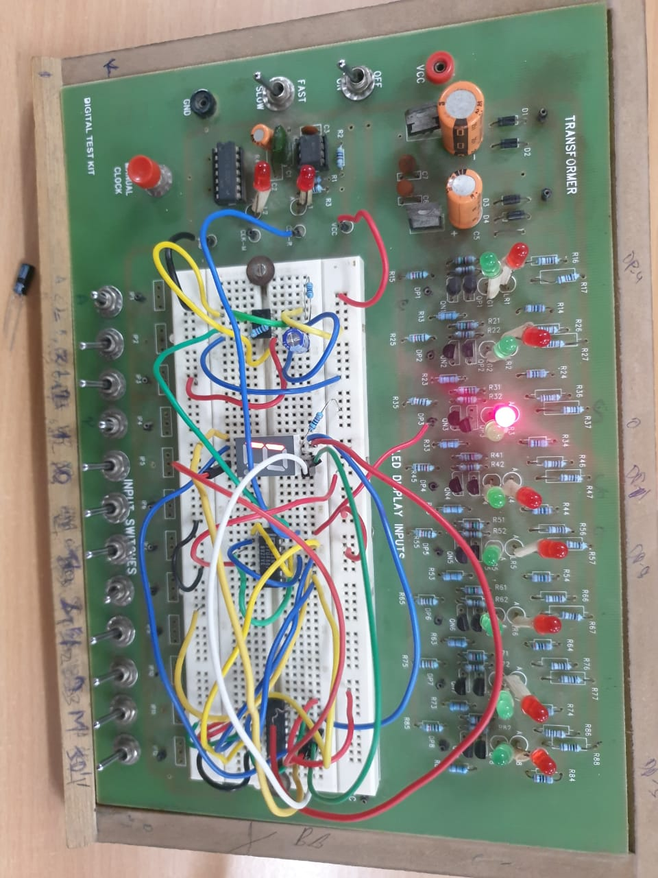

**Conclusion**

* The decade counter is working as expected.

TinkerCAD simulation link:

<https://www.tinkercad.com/things/hH6jvQrbDwf-exp-6-part-a/editel?sharecode=hxfp4KL4Tl9HKRvpstpkog7oQNlCV_2Cb8EJgv7djEQ>